Foreign Exchange Prediction using LSTM Optimized with Genetic Algorithm

**Daniel Budi Prasetyo, Cyprianus Kuntoro Adi, S.J. M.A., M.Sc., Ph.D.**

Teknik Informatika

Universitas Sanata Dharma Yogyakarta

e-mail: [danielbudip789077@gmail.com](mailto:danielbudip789077@gmail.com), …

***Abstract***

*Foreign exchange (Forex) was one of the largest financial markets in the world, with more than $5.1 trillion being traded every day. In this study, Long Short-Term Memory (LSTM) and Genetic Algorithm Long Short-Term Memory (GA-LSTM) were used to predict the price patterns of USD, EUR, and SGD. The data was taken from the Google Finance website over a period of 5 years, totaling about 1977 data points for USD and EUR, and 1956 data points for SGD. In some scenarios, optimization with Genetic Algorithms was successful in reducing error values, although this did not always apply to all cases. The most optimal LSTM model for predicting USD, EUR, and SGD data against IDR obtained an MAE of around 41.27, 60.89, and 13.04 respectively. However, if we were to predict future prices, the EUR model would need to be improved further to obtain a smaller error value.*

***Keywords****: Foreign exchange, Long Short-Term Memory, Genetic Algorithm*

**1. Introduction**

Foreign exchange (Forex) is one of the world's largest financial markets, with more than $5.1 trillion traded every day. The intricacies and fluctuations inherent in Forex render price prediction challenging [1], particularly in regions like Indonesia where fostering sustainable economic development and enhancing citizens' welfare is paramount. Exchange rate instability poses a significant deterrent to investor confidence, potentially hindering Indonesia's developmental progress, given the substantial role foreign investors play in its economic growth [2]. The consequential impact of such instability cannot be overstated, especially considering the pivotal role that foreign investors have historically played in propelling Indonesia's economic growth trajectory forward. As such, mitigating the adverse effects of exchange rate fluctuations assumes paramount importance, necessitating robust predictive models and strategic interventions to navigate the complexities of the Forex landscape effectively.

The realm of Deep Learning, celebrated for its triumphs in diverse domains like image recognition, natural language processing, and speech recognition, has garnered considerable attention for its applicability in forecasting exchange rates [3, 4, 5]. This burgeoning interest is evident across the global financial landscape, where financial researchers have dedicated substantial efforts to studying and analyzing the intricacies of both stock and Forex markets. The advent of artificial intelligence has revolutionized investment strategies, precipitating a notable uptick in the utilization of Deep Learning models by investors seeking to predict and analyze stock and Forex prices. Over time, empirical evidence has firmly established the efficacy of Deep Learning methodologies in successfully predicting fluctuations in both stock and Forex prices [5]. This convergence of technological innovation and financial analysis underscores the evolving nature of investment practices and the increasing reliance on sophisticated computational tools to navigate the complexities of modern financial markets.

Based on one of the literature, it's evident that the Long Short-Term Memory (LSTM) model outshines its counterpart, the Recurrent Neural Network (RNN), exhibiting superior performance characterized by smaller Root Mean Square Error (RMSE) and Mean Absolute Error (MAE) metrics [6]. Building upon this foundation, we endeavors to harness the predictive prowess of the LSTM model to forecast foreign exchange prices over the past five years. By leveraging this advanced neural network architecture, we aim to enhance the accuracy and reliability of our predictions, thereby facilitating more informed decision-making in the volatile realm of foreign exchange markets. Furthermore, to further refine and optimize the LSTM model, we propose the integration of Genetic Algorithms (GA). By iteratively fine-tuning the model parameters through GA, we anticipate a reduction in errors from the initial model, thus bolstering the predictive capabilities of our approach.

**2. Research Method**

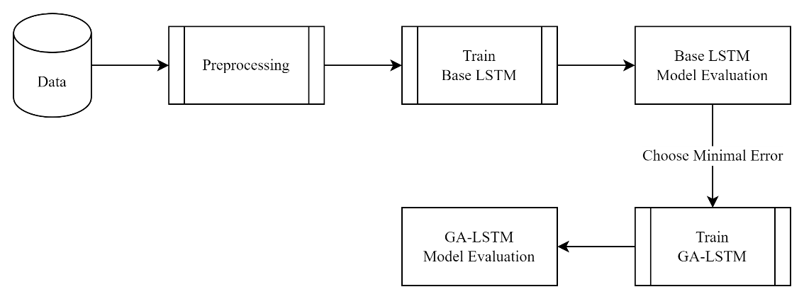

Figure 1. Research Procedure

The research procedure consists of the following steps (Fig. 1):

1. Data acquisition, data for this research acquired from Google Finance and consist of daily closing purchase prices for the USD, EUR, and SGD foreign currencies. The dataset covers a timeframe of about five years, from January 1, 2018, to May 31, 2023, encompassing a total of 1977 data points for the USD and EUR currencies, and 1956 data points for the SGD currency.
2. Data preprocessing, involves transforming the initially unrefined data into a clean format suitable for model training. This entails several steps such as identifying and handling outliers, normalizing the data, implementing sliding window techniques, and partitioning the dataset using either splitting or cross-validation techniques.
3. Train LSTM, Base LSTM has 3 layers with cell numbers of 128, 64, and 32 respectively. The model will be trained using various parameters including, number of layers, sliding window size, train-test split or fold size from cross-validation. Details of the model and tested parameters can be seen in Fig. 2 and Table 1.
4. LSTM evaluation, the model that has been trained will be tested using previously split data to get the error value. The matrix used to get it is MAE.
5. Train GA-LSTM, choose parameters from Base LSTM that produce a model with minimum MAE in each sliding window, where the number of cells in LSTM will then be optimized using GA. The number of generations used for GA is 50, where mutations will occur every generation in multiples of 5. After getting the optimal number of cells for each LSTM layer, the model will be retrained using the optimal results obtained through GA.
6. GA-LSTM evaluation, the retrained model will be tested using previously split data to get the MAE.

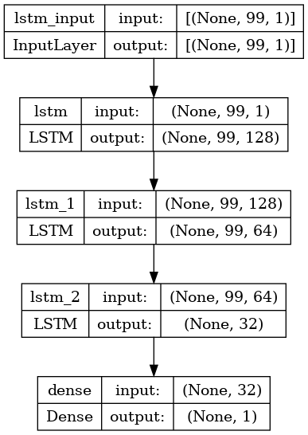

Figure 2. Base LSTM Architecture

Table 1. Tested Parameter

|  |  |  |
| --- | --- | --- |
| LSTM Layers | Sliding Window | Split or Fold |
| 1 | 5 | 0.8 / 5 |
| 2 | 10 | 0.9 / 10 |
| 3 | 20 |  |

**3. Results and Analysis**

In this section, it is explained the results of research and at the same time is given the comprehensive discussion. Results can be presented in figures, graphs, tables and others that make the reader understand easily [2], [5]. The discussion can be made in several sub-chapters.

**3.1. Sub Bab 1**

xx

**3.2. Sub Bab 2**

yy

**4. Conclusion**

Provide a statement that what is expected, as stated in the "Introduction" chapter can ultimately result in "Results and Discussion" chapter, so there is compatibility. Moreover, it can also be added the prospect of the development of research results and application prospects of further studies into the next (based on result and discussion).

**References**

|  |  |
| --- | --- |
| [1] | M. S. Islam and E. Hossain, "Foreign exchange currency rate prediction using a GRU-LSTM hybrid network," *ELSEVIER,* no. 3, 2021. |
| [2] | A. Kartikadewi, L. A. A. Rosyid and A. E. Putri, "Prediction of Foreign Currency Exchange (IDR and USD) Using Multiple Linear Regression," *International Journal of Engineering and Techniques,* vol. VI, no. 2, 2020. |
| [3] | N. Lina, L. Yujie, W. Xiao, Z. Jinquan, Y. Jiguo and Q. Chengming, "Forecasting of Forex Time Series Data Based on Deep Learning," *ELSEVIER,* no. 147, pp. 647-652, 2019. |
| [4] | M. Yasir, M. Y. Durrani, S. Afzal, M. Maqsood, F. Aadil, I. Mehmood and S. Rho, "An Intelligent Event-Sentiment-Based Daily Foreign Exchange Rate Forecasting System," *Applied Science,* vol. IX, no. 15, p. 2980, 2019. |
| [5] | Z. Hu, Y. Zhao and M. Khushi, "A Survey of Forex and Stock Price Prediction Using Deep Learning," *Appl. Syst. Innov.,* vol. IV, no. 9, 2021. |
| [6] | Q. Yaxin and Z. Xue, "Application of LSTM Neural Network in Forecasting Foreign Exchange Price," *Journal of Physics: Conference Series,* vol. 1237, no. 4, 2019. |